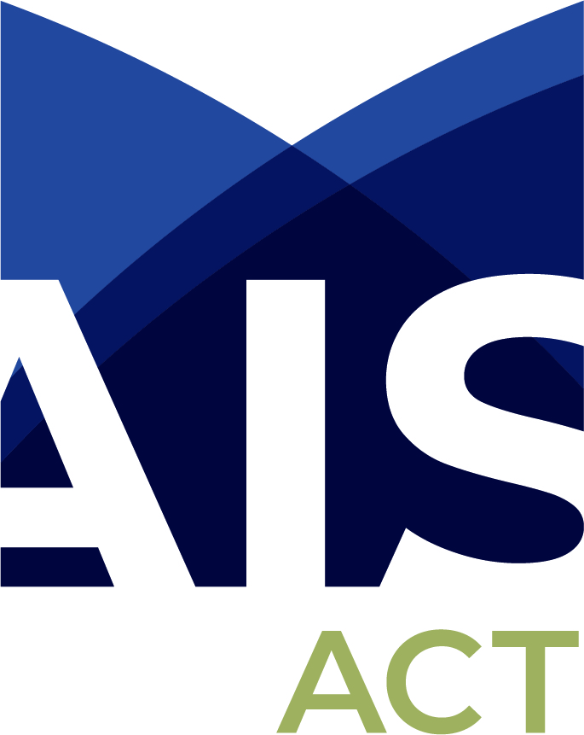

Review of the Universal Access National Partnership

Submission by

The Association of Independent Schools of the ACT (AISACT)

October 2019

Introduction

The Association of Independent Schools of the ACT (AISACT) welcomes the opportunity to provide a submission regarding the Review of the Universal Access National Partnership

The ACT independent school sector provides a diverse range of schooling options to families living in the ACT and in the surrounding region, and to families needing boarding school facilities.

Independent schools play an important role in providing educational alternatives to those provided by the government sector. The ACT community is multicultural and diverse and the independent school sector reflects this. It should be a basic premise that parents should have a choice, where possible, about where their child is educated. There are many reasons underpinning parental choice, including pedagogical style, learning environment, faith, values, gender, school culture and pastoral structures.

Independent schools have emerged in direct response to community demand and have a long history of accepting an educational leadership role in the national capital, and a shared role with governments, in setting up schools in the ACT.

In the end, it is about parents finding a school which provides the best ‘fit’ and, therefore, the best opportunities for success for their child.

All students, irrespective of where they are educated, are entitled to a high quality of education, and it is the responsibility of governments to provide a suitable level of funding for all students to achieve quality outcomes.

The Association represents all eighteen independent schools which together educate 14,912 students, or around 19% of the ACT school population. Enrolment in Canberra’s Independent schools has historically been very strong, and have seen a 21% increase in student enrolment over the past 10 years.

Currently twelve of the eighteen ACT independent schools provide preschool programs four year olds as part of their provision of education.

The national partnership funding for universal access has only been provided to the government sector in the ACT. Growth in the preschool numbers in the nongovernment sectors since 2011 has been 178%, with an 11.5% growth in the government sector.

Consultation Questions

QUESTION 1:
To what extent have the UANP policy objectives, outcomes and outputs been achieved?

The objective of the UANP is to “maintain universal access to, and improve participation in, affordable, quality early childhood education programs for all children”. Specifically, the purpose is to ensure that every child in Australia has access to a minimum of 600 hours per year of preschool delivered by a qualified early childhood teacher in the year before full-time school, in a way that meets the needs of families and while ensuring that cost is not a barrier.

Funds under the UANP to support the provision of 15 hours per week have never been made available to all providers in the ACT: currently only ACT government preschools receive this funding. This is in stark contrast to other Australian states wherein early childhood services across all sectors receive funding.

A large number of AISACT schools provide preschool programs, and have done so for many years, without any support from the ACT or Federal governments.

The demand for early childhood services has grown over the years, with 12 Member schools providing a preschool program for four year olds. In many cases these services exceed the 15 hours available in the ACT government preschools. This offers continuity of care, which is especially important for disadvantaged families and for children with additional needs. In addition 11 schools already provide programs for three year olds. Many of these programs operate for longer hours, thus meeting the needs of their families. In many instances, affordability is ensured by families accessing the federal government’s Child Care Subsidy.

Children experiencing vulnerability / disadvantage, benefit from the stability offered by “continuity of care” in one setting. Unfortunately ACT Government preschools effectively offer a part-time option only, which does not necessarily align with the needs of all families.

QUESTION 2:
What should the UANP target and measure, and how should data be collected and used?

The UANP’s performance indicators, benchmarks and targets focus effort on maintaining universal access to and improving participation in affordable, quality preschool, particularly for Aboriginal and Torres Strait Islander children and children experiencing vulnerability and disadvantage.
We are interested in your views about the focus of the UANP funding agreement and whether performance or success is being tracked and measured in the right way.

UANP should target and measure both participation and attendance. It is well understood that attendance is a critical prerequisite for improving outcomes for all four year olds.

AISACT supports the position that data and feedback from parents should be sought to ascertain satisfaction levels regarding the number of hours/days currently offered, and whether there are alternatives which might better respond to the needs of families. The option currently offered in the ACT by government preschools is a one size fits all model.

AISACT suggests that parent satisfaction and parent preference data be collected. This should include data related to the use of multiple settings used by parents in an effort to maximise affordability of childcare: that is the use of one setting which provides a free 15 hour service is often needed to be complemented by accessing additional childcare hours in a different setting.

AISACT encourages the collection and sharing of data pertaining to four year olds who are not attending any preschool program. Access to this information can potentially inform better planning and focus of services into the future.

QUESTION 3:
Are the current UANP arrangements efficient and effective and how could the efficiency, effectiveness and equity of UANP funding be improved?

Notwithstanding progress to date under the UANP, there may be opportunities to improve the impact of this national funding for preschool in the year before full-time school, particularly for Aboriginal and Torres Strait Islander children, children in regional and remote areas, and children experiencing vulnerability and disadvantage.
We are interested in your views on the use of UANP funding, based on your own experience and knowledge of the system either within your local community or more broadly. We also welcome your perspectives on the appropriateness of a performance-tied funding framework.

UANP funding should be extended to all government and nongovernment schools, and other services, who are providing a four-year-old preschool program staffed by qualified early childhood teachers.

The opportunity for a sector blind approach of government support for the provision of early years education for three and four year olds, to meet the needs of all students across the ACT should be the priority. Access to early education and care is provided in a range of settings in the ACT, not just in government preschools and, as such, all should be considered equally.

Performance-tied funding requires further clarification and transparency before we are in a position to comment.

QUESTION 4:
How does the preschool system operate across States and Territories and settings?

The context in which the National Partnership agreement operates is important to understanding its achievements and future directions. The UANP allows for flexibility in how and where preschool is delivered; it can be delivered in schools, stand-alone preschools or within centre-based day care. It can reflect different approaches and involve connections to other services – as long as it is delivered by a teacher whose qualifications meet National Quality Framework requirements.
The Review is interested in understanding more about how models of delivery vary to meet the contexts and needs of different communities or different cohorts of children. This includes understanding how that UANP funding complements other government funding (local government, State and Territory, and Australian Government) and any private investment, particularly with respect to lifting participation in quality preschool.
Please note that the Review is not reviewing the specific funding and delivery arrangements in States and Territories, but how the UANP complements existing models of preschool delivery.

AISACT schools offer a range of different options for families rather than the “one size fits all” model currently operating in ACT government preschools.

In comparison, nongovernment school options include a choice of day, hours and outside school hours care. This provides a considerable benefit to families as it means they do not need to access separate services for the periods when a child is not in the school program.This ensures seamless transitions throughout the day for children as they are able to remain in the one learning environment, thus ensuring each child familiarity of both surroundings and relationships

Many AISACT schools have received the Exceeding Standard from the regulatory body, with a number being awarded an excellent rating from ACECQA. They are therefore exemplars of excellent practice in the ACT

Currently in the ACT, UANP funding discriminates against and excludes non-government preschool program providers. The funded model (ACT government preschools) is limited to an option that is neither flexible in hours of operation, nor responsive to families’ needs, nor conducive to continuity of care. These elements are commonly associated with early childhood best practice and are key features of the provision of four year old preschool programs in nongovernment schools.

QUESTION 5:
Based on your experiences, should changes should be made to future national policy on preschool for children in the year before full-time school, and why? What improvements would these changes make? What works well with the current UANP arrangements?

This is an opportunity to provide any additional comments that you think are relevant to the design of future preschool arrangements, including taking into account each State and Territory’s context and the interaction of the UANP funding and other funding including Child Care Subsidy payments.
For example, we would appreciate any further views on how funding might be better used to maintain and improve universal access to preschool and learning outcomes for children, particularly for Aboriginal and Torres Strait Islander children, children in regional and remote areas, and children experiencing vulnerability and disadvantage. We would also welcome suggestions on changes that could usefully be made to the UANP agreement itself (e.g. its objective, outcomes, outputs indicators, benchmarks and targets) to ensure children receive the full benefits of accessible, affordable quality preschool.

UANP funding needs to become genuinely “universal”, across all ACT preschool program providers. The AISACT strongly supports the position that the best option for families in the ACT, to support their young children is for the Universal Access for four year olds to be expanded to include those students attending Independent schools. This should also extend to the phased implementation of three year old Universal Access.

As previously articulated, the UANP funding should be extended to all sectors, government and nongovernment schools, and other services, who are providing a four year old preschool program staffed by qualified early childhood teachers. This will ensure the continued financial viability of longstanding early childhood service providers.

Andrew Wrigley
Executive Director
Association of Independent Schools of the ACT
October 2019

